/Python Lab 1

1.Installing Python on Windows

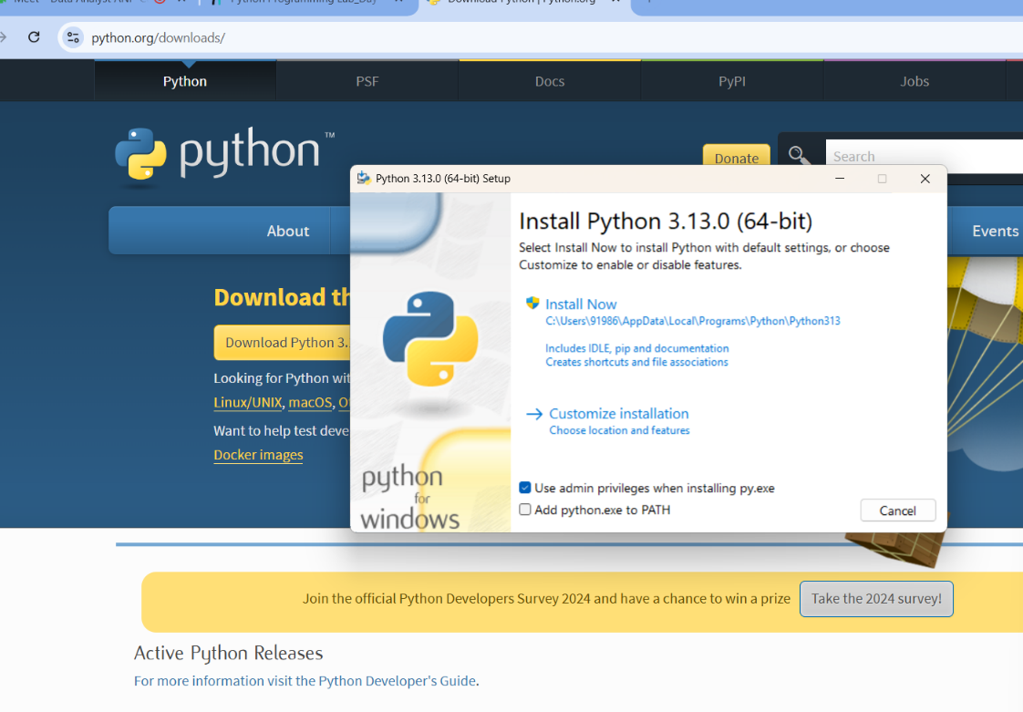

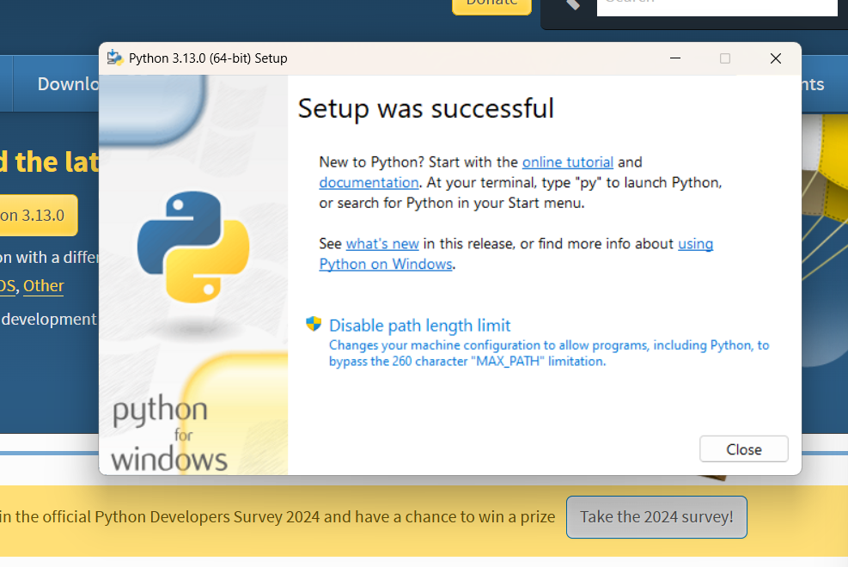

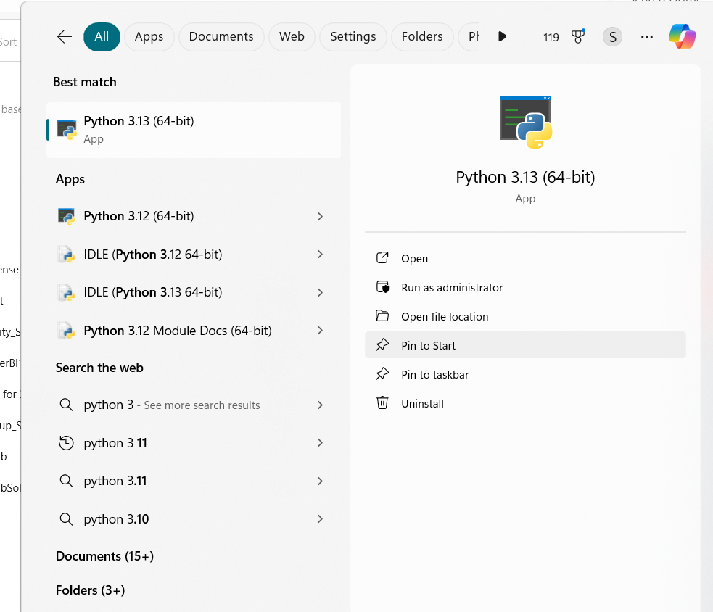

2. Demonstrate about Basics of Python Programming:

i. Running Python Interpreter:

ii. Running Python Scripts in IDLE (Integrated Development and Learning Environment):

iii. Indentation.

i.

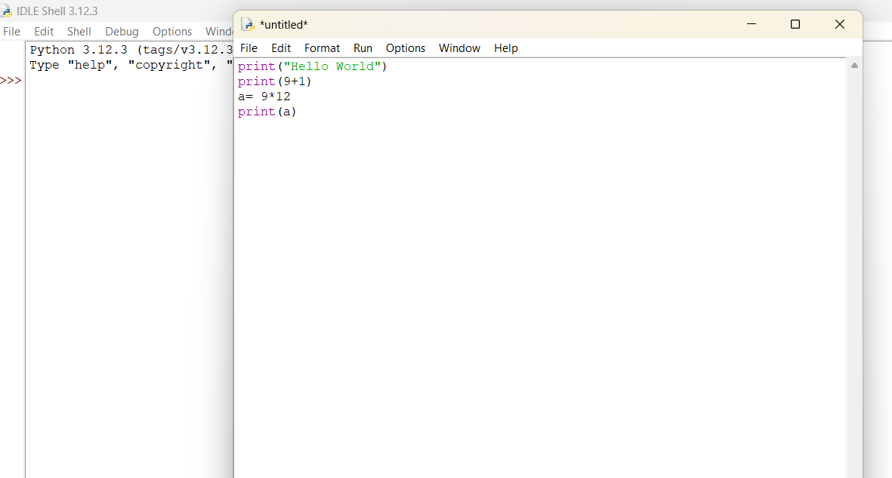

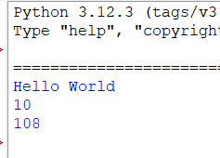

ii.

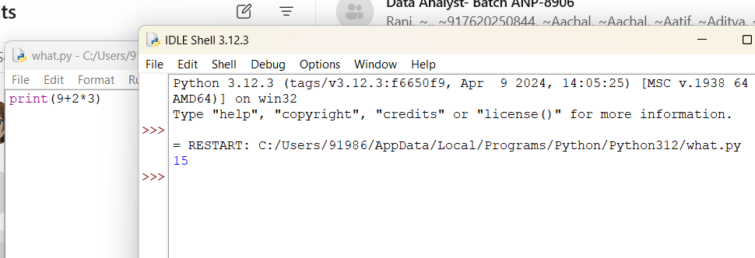

iii.

